2.6.1 User Registration and Role Assignment
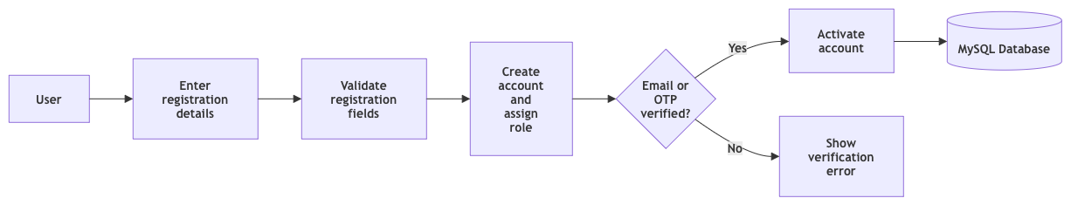
Figure 1: Functional view for user registration and role assignment

2.6.2 User Login and Role Based Dashboard
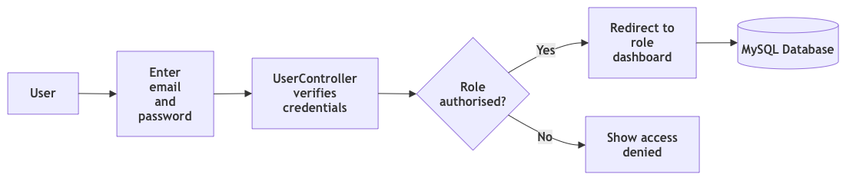
Figure 2: Functional view for user login and role based dashboard

2.6.3 Password Reset and Secure Token
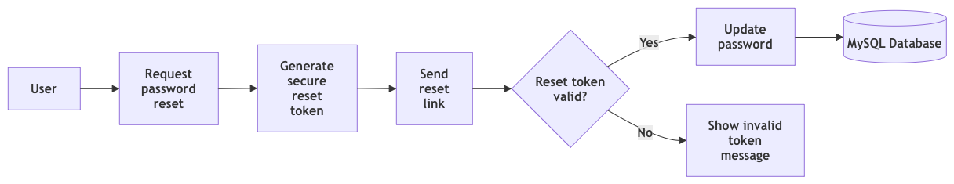
Figure 3: Functional view for password reset and secure token

2.6.4 Administrator Account Management
Figure 4: Functional view for administrator account management

2.6.5 Digital Prescription Creation
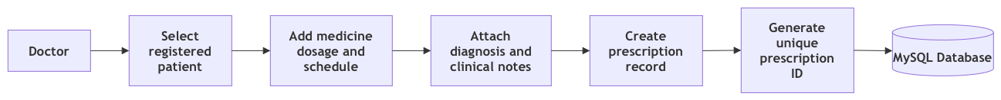
Figure 5: Functional view for digital prescription creation

2.6.6 Edit or Cancel Prescription
Figure 6: Functional view for edit or cancel prescription

